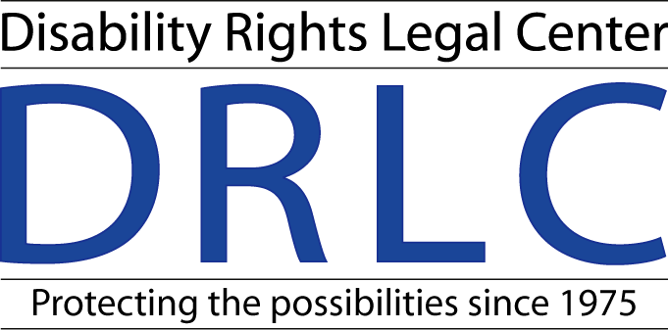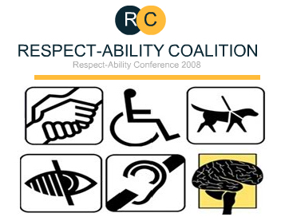

California Health Care Accessibility Survey Results

FACT SHEET
July 2008

This fact sheet provides insight into the most common obstacles that people with disabilities in California face when attempting to access health care.
Through the administration of a state-wide survey on the accessibility of health care facilities for people with disabilities, many key problem areas were brought to attention.

Overview
This survey was conducted by the Respect-ABILITY Coalition, a statewide group of disability rights and service organizations in California, and was completed by consumers who could send their surveys by mail, fax, and e-mail, or call and have their responses documented over the phone. The survey was available in English, Spanish, Large Print, Braille, and Compact Disc. Questions on the survey addressed barriers in service and the environment that prevented equal access to health care.

It was clear from the results of the survey that many barriers still exist at health care facilities, despite state and federal laws that require removal of these barriers. Barriers to access were not limited to physical obstacles, but included a lack of program accessibility due to a lack of services provided or adequate accommodations and/or product formats.

The survey documented the inability and at times unwillingness of some facilities to ensure the basic rights of individuals.
These rights included:
- Removal of physical barriers
- Availability of sign language interpreters
- Information in alternate formats
- Accessible medical equipment
- Accessible restrooms

Common Obstacles
This survey showed that laws are not enforced to the extent that medical facilities have made the changes necessary to guarantee the rights of people with disabilities as well as compliance with the law.

This consumer based survey allowed the issues in question to be represented quantitatively. Those who completed the survey tended to focus on the obstacles they faced as a result of their particular disability. This trend resulted in responses of “Don’t Know” for many of the questions (e.g. a wheelchair user not knowing whether sign language interpreters are available).

Despite this, it can be determined from the survey results that disability sensitivity training is needed for all staff, but especially the frontline staff. Moreover, many steps still need to be taken to remove entrance barriers and increase accessibility to these facilities.

The most common issues pertaining to entrance barriers included:
- Improper signage
- Heavy doors or narrow doorways
- High countertops

Recommendations
To address these issues it is recommended that disability awareness and sensitivity training be required of all staff on a periodic basis. Moreover, there is a lack of knowledge of what the law requires of these facilities, and therefore health care providers may not be aware when their facilities are not in compliance with the law. These trainings will increase staff knowledge of current laws and better their understanding for the obstacles people with disabilities face.

The creation of an on staff ADA coordinator position would benefit the staff as a whole. This position does not necessarily imply hiring a new employee, but rather the incorporation of a firm understanding of disability laws into an existing staff member’s job description. This employee would be a valuable source of information for all disability related issues.

Increased expenses are often a result of taking the necessary steps to ensure accessibility and compliance. It is often the case that interpreters and other services would not be provided to the costs involved in provided these services.
There must be a discussion regarding increased funding for publicly funded facilities, as well as an incorporation of compliance with state and federal access laws into any overhaul of the health care system. Incentives, such as tax breaks, would encourage private clinics to comply and accommodate all individuals.

Conclusion
It is clear that a lack of resources has led to subpar enforcement of state and federal laws that are meant to ensure equal access to health care for individuals with disabilities. This fact compounded with a lack of knowledge and sensitivity from staff creates an environment of inaccessibility. This environment creates not only physical access issues, but poses service related obstacles to program access as well.

Although there are instances of compliance, the survey proved that there remains much progress to be had. Most facilities were compliant in some areas, however, not compliant in others. Equality of access to health care facilities can be achieved through stricter enforcement of the law, a robust incentives program, and routine staff trainings.

For more information on the Respect-ABILITY Coalition, please visit our web site: www.respectabilitycoalition.org

The Respect-ABILITY Health Care Accessibility Survey was funded by a generous grant from The California Endowment.



